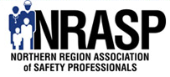
David & Jamie Dyck –
EXPLOSION MAN – The Man Who Lived
www.NRASP.com
2015 NRASP Annual Safety Conference

The NRASP Annual Safety Conference will be held on November 9 and 10 at the Hilton Garden Inn in Fargo, ND. NRASP is a Fargo-Moorhead and surrounding areas non-profit volunteer organization that promotes health and safety.
- We have 2 exceptional key note speakers again this year – Travis Jacobson of the Grand Forks Police Department and David & Jamie Dyck, “Explosion Man – The Man Who Lived”
- As always, excellent training opportunities will be provided in the breakout sessions.
- NRASP Fall Conference continues to be an extreme value for you and your organization.
- Networking with several vendors and other safety professionals is one of the many benefits of attending.
- The NRASP conference is also a great opportunity for vendors to share information regarding your professional services and products.
- We welcome involvement from sponsors of the event for supporting safety!
A complete list of course offerings and vendor booth information will be posted at a later date.
Hope we will see you there!
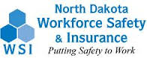
Conference made possible through WSI’s Step Grant!

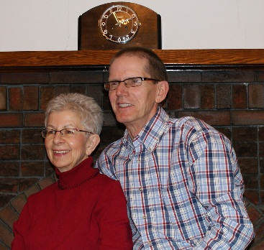
PPE – Wear it for YOU
In 2003 David Dyck was involved in a work place explosion. David’s powerful true story is of surviving the violent explosion that occurred while he was performing a routine maintenance procedures. He attributes the fact he was wearing PPE as the reason he is here today to share his story. His story demonstrates no matter how safely you conduct yourself in the workplace, incidents can happen…Being prepared can save your life.
David’s wife Jamie joins with David to illustrate that the incident didn’t just happen to David.
Travis Jacobson, Grand Forks Police Department

Drugs and Society
Drugs and Society is a 1.5 hour presentation on what we are dealing with this day in age when it comes to drug use amongst our society. During the presentation, Sgt. Jacobson will talk about what a DRE (Drug Recognition Expert) is and how a DRE can be utilized with other agencies and the public. He will also talk about what drugs are new and upcoming that we are seeing locally in our area like Fentanyl, Heroin, Meth, etc. Sgt. Jacobson will explain how these drugs are used and what effects the user will have. Sgt. Jacobson will also talk about signs and symptoms that a user will exhibit when under the influence of certain drugs. He will also touch on drug addiction and how to tell when someone is suffering from addiction by explaining what to look for. Sgt. Jacobson will show many pictures of drug paraphernalia and explain how the user uses them. He’ll also touch on where and how users hide their drugs and paraphernalia. Sgt. Jacobson will also talk in depth about the abuse of prescription meds and how people are getting these drugs in staggering numbers.

Sgt. Jacobson is a 14 year veteran of the Grand Forks Police Department. He started his law enforcement career with the Grand Forks County Sheriff’s Department after receiving his Bachelor’s Degree in Criminal Justice at the University of North Dakota in 1998. In 2001, Sgt. Jacobson took a job at the Grand Forks Police Department where he has served as a Field Training Officer, Hostage Negotiator, Drug Recognition Expert, Drug Recognition Expert Instructor and Detective. Sgt. Jacobson was named the Course Manager for the state of North Dakota’s DRE Program in 2010.
Sgt. Jacobson is currently assigned in the Criminal Investigations Bureau where he supervises the Property Crimes Division. Sgt. Jacobson has always been very busy with the education and teaching of alcohol and drug use/abuse.

